**Choosing Appropriate Statistical Analyses**

**DVs ProdTaken**

##Matrix Correlation observation:

Exam Dependent Variable ProdTaken:

only 797 customers bought product, 3331 customers did not.

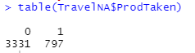

Independent variables that are highly correlated with our DV ProdTaken are:

* 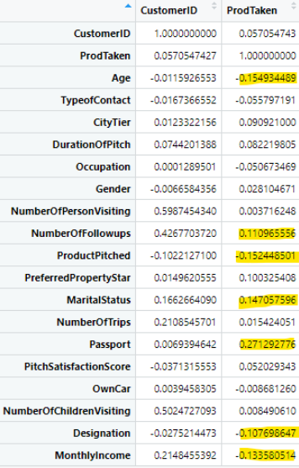Passport 0.271
* MaritalStatus 0. 147
* NumberOfFollowups 0.11
* Designation -0.107
* MonthlyIncome -0.133
* Age -0.15
* ProductPitched -0.15

**Explore Continuous IVs for those who bought products – Stepwise regression**

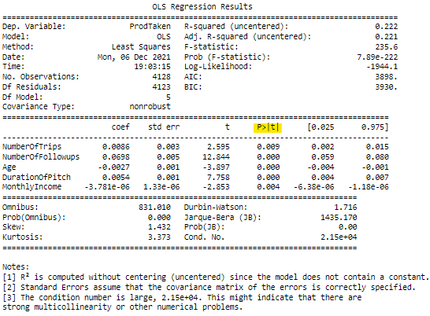

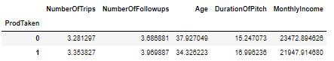

People who taken product:

* have average Age of 34 with monthly Income of 21, 948.
* Receive average 3.97 numbers of followings, ranking from 1 to 6.
* Receive pitch with average duration of 17.
* Take average of 3.4 trips

People who did not taken product:

* have average Age of 38 with monthly Income of 23, 473.
* Receive average 3.69 numbers of followings, ranking from 1 to 6.
* Receive pitch with average duration of 15.
* Take average of 3.3 trips

**Exam correlation between Categorical IVs and ProdTaken – Independent Chi-Square**

1. 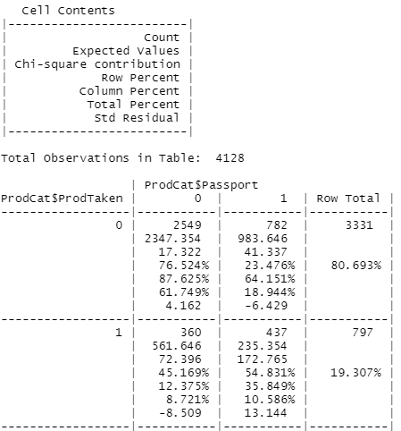**Passport**

**Observation**:

* 61% potential customers without passport did not make a purchase.
* 19% potential customers with a passport did not make a purchase.
* 10% customers with a passport made a purchase.
* 8% customers without passport made a purchase.

Among potential customers who did not make a purchase, 76% did not have a passport.

Among those customers who made a purchase the percentages of whether they have a passport or not are pretty close with those who have a passport higher by 9%.

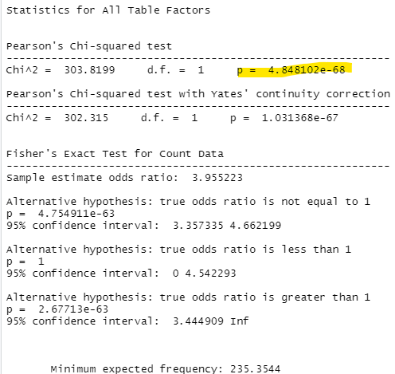Only 36% Customer with a passport actually made a purchase.

**Interpret** **Results**

Since all of our expected values are above 5, our data pass the assumption.

With a p value of 4.848102e-68, this analysis is significant, meaning that having a passport or not does in fact make a difference in whether potential customer makes a purchased.

* We want to either target customer with a passport preferably for current packages.
* More importantly edit or create more packages better suite our customers, especially the local customers.

1. **MaritalStatus**

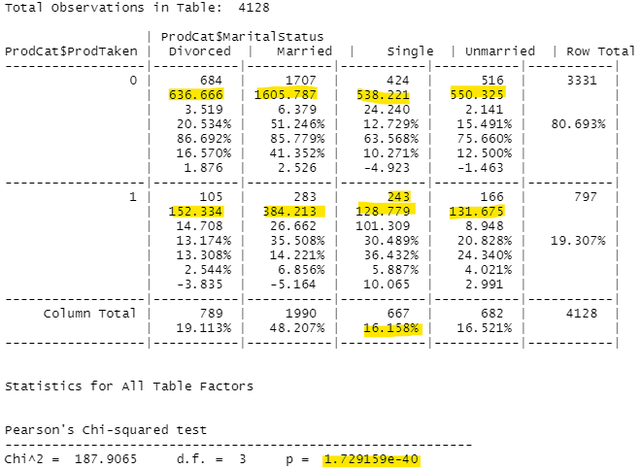

* 41% married potential customers did not make a purchase.
* 16% divorced potential customers did not make a purchase.
* 12% unmarried potential customers did not make a purchase.
* 10% single potential customers did not make a purchase.
* 9% married potential customers made a purchase.
* 6% single potential customers made a purchase.
* 4% unmarried potential customers made a purchase.
* 2% divorced potential customers made a purchase.
* Majority of potential customers in all marital status did not make a purchase with married couple ranking the highest.
* Since married potential customers has the highest percentage in total customers, it is understandable that this group rank the highest in both purchase or not.
* Divorced customers rank 2nd in total customer base but last in packages purchased.
* Single group has the lowest percentage in total customers base but rank 2nd in purchases made.

**Interpret** **Results**

Since all of our expected values are above 5, our data pass the assumption.

With a p value of 1.729159e-40, this analysis is significant, meaning that marital status in fact make a difference in whether potential customer makes a purchased.

Look like we want to target married couples. However, the current packages are not as appealing to them as packages for single.

Single customer seem to response best to our current packages and married couple still in the lead although only by 3%.

1. **Designation**

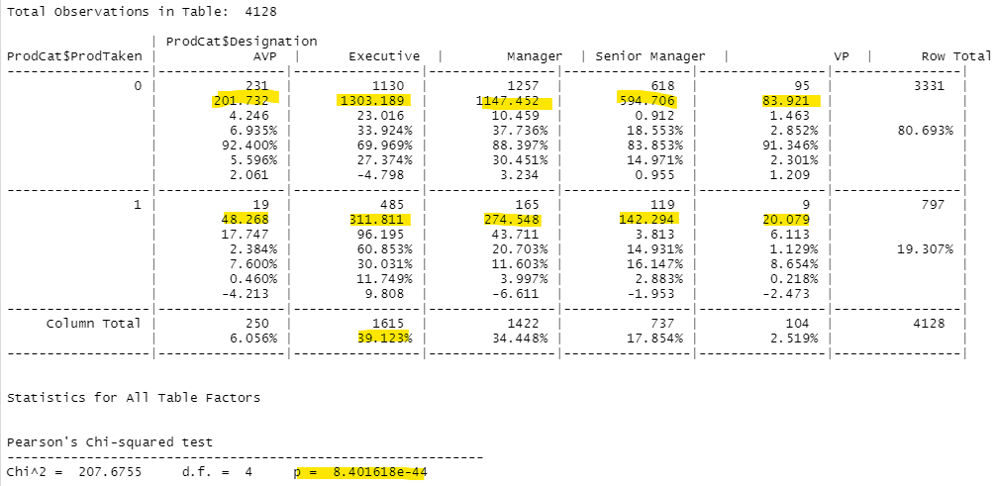

* 30% Manager Designation did not result in a purchase of packages.
* 27% Executive Designation did not result in a purchase of packages.
* 15% Senior Manger Designation did not result in a purchase of packages.
* 5% AVP Designation did not result in a purchase of packages.
* 2% VP Designation did not result in a purchase of packages.
* 12% Executive Designation result in a purchase of packages.
* 4% Manger Designation result in a purchase of packages.
* 3% Senior Manager Designation result in a purchase of packages.
* 0.5% AVP Designation result in a purchase of packages.
* 0.2% VP Designation result in a purchase of packages.
* Executive and Manager are among the highest group of Designation however, Executive seem to make more sale than Manager.

**Interpret** **Results**

Since all of our expected values are above 5, our data pass the assumption.

With a p value of 8.401618e-44, this analysis is significant, meaning that Designation in fact make a difference in whether potential customer makes a purchased.

We want to investigate and duplicate how our current executives make their sales.

1. **ProductPitched**

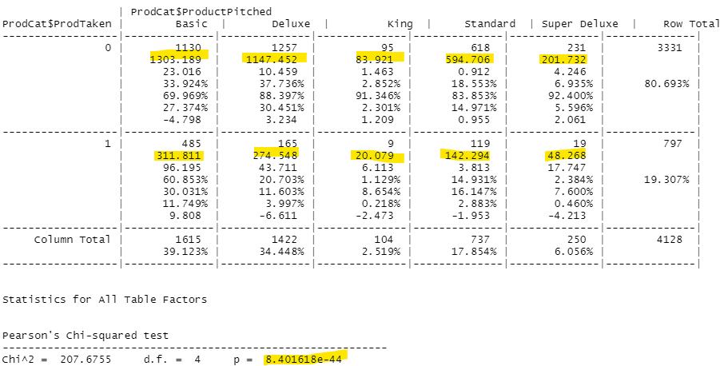

* 30% Deluxe packages pitched did not result in a purchase.
* 27% Basic packages pitched did not result in a purchase.
* 15% Standard packages pitched did not result in a purchase.
* 6% Super Deluxe packages pitched did not result in a purchase.
* 2% King packages pitched did not result in a purchase.
* 12% Basic packages pitched result in a purchase.
* 4% Deluxe packages pitched result in a purchase.
* 3% Standard packages pitched result in a purchase.
* 0.46% Super Deluxe packages pitched result in a purchase.
* 0.2% King packages pitched result in a purchase.
* Majority of the packages pitched are Basic and Deluxe. Among those, Basic packages made the most sale. A small percentage of Deluxe packages pitch actually made a sale.

**Interpret** **Results**

* Since all of our expected values are above 5, our data pass the assumption.
* With a p value of 8.401618e-44, this analysis is significant, meaning that product pitched in fact make a difference in whether potential customer makes a purchased.

It worth investigate and duplicate positive feathers in our Basic packages to other packages to attract more sale.

**Summary Result:**

For current packages, target customers who more likely to taken a product are:

* either single or married couples
* with a passport preferably
* with monthly Income of 21, 948
* have average Age of 34
* Receive average 3.97 numbers of followings, ranking from 1 to 6.
* Receive pitch with average duration of 17.
* Take average of 3.4 trips
* Was help by executives designation.
* pitched Basic packages